**Data Structures Workspace Config & Install Manual**

* This document will provide detailed instructions for any beginner or returning data structures student interested in interacting and learning from the data structures eclipse workspace. Instructions on how to clone our GitHub repository to your local development environment as well as instructions on how to download a copy of the workspace for use are contained below.

Table of Contents

Table of Figures 1

Requirements 1

Software Requirements 1

Minimum Hardware Requirements 1

Recommended Hardware Requirements 1

Working with the Data Structures workspace in your IDE 1

Using Smart Import to Load the Workspace into Eclipse 1

Manually Downloading the Workspace from Github 1

# Table of Figures

Figure 1 Diagram of Branch Selection in Repository 1

Figure 2 Diagram of Downloading Repository as ZIP 1

Figure 3 Diagram of Eclipse Startup 1

Figure 4 Diagram of Eclipse Import Using Existing Workspace 1

Figure 5 Diagram of First Page in the Import From Existing Workspace Wizard 1

Figure 6 Diagram of Selecting Downloaded GitHub Workspace in File Explorer 1

Figure 7 Diagram of Final Page in Eclipse Import From Existing Workspace Wizard 1

Figure 8 Diagram of Finished Eclipse Import From Existing Workspace 1

# Requirements

## Software Requirements

* Java SE 17 ([Download](https://www.oracle.com/java/technologies/javase/jdk17-archive-downloads.html))
* Git command line tool (https://docs.github.com/en/get-started/quickstart/set-up-git) or [eGit](https://www.eclipse.org/egit/#:~:text=EGit%20is%20an%20Eclipse%20Team,history%20very%20fast%20and%20versatile.) for version control natively in Eclipse
  + additionally, an active github account is needed
* Eclipse 2021 IDE for Enterprise Java and Web Developers – 2021-12 ([Download](https://www.eclipse.org/downloads/packages/release/2021-12))

## Minimum Hardware Requirements

* Required Java version:
  + Java SE 17 ([Download](https://www.oracle.com/java/technologies/javase/jdk17-archive-downloads.html))
* Memory:
  + 512 MB
* Free Disk Space
  + 500 MB
* Processor Speed
  + 1 GHZ

## Recommended Hardware Requirements

* Required Java version:
  + Java SE 17 ([Download](https://www.oracle.com/java/technologies/javase/jdk17-archive-downloads.html))
* Memory:
  + 1GB or more
* Free Disk Space:
  + 1GB or more
* Processor Speed:
  + 1.5 Ghz or more

# Working with the Data Structures workspace in your IDE

## Using Smart Import to Load the Workspace into Eclipse

* Ensure the required prerequisites are installed and functioning. We will use eGit to import the workspace from GitHub.
* Create a folder in your desired directory to store the eclipse workspace. Browse to that folder when starting up Eclipse and **Launch** to initialize the workspace.
* Inside Eclipse:

File -> Import -> Git -> Projects from Git (with smart import) -> Clone URI

* For URI enter in the https url from the repository

<https://github.com/samthangiah/Spring-2022---Data-Structures.git>

* Authenticate by providing your github username and password. Sometimes, you will need to generate a personal access token when your password does not authenticate you. Follow this [stackoverflow](https://stackoverflow.com/questions/54485527/authentication-failed-cannot-clone-remote-repository-by-git-only-occurred-in) post as a workaround.
* Select the master branch to clone from the repository and click **Next**.
* Click **Next** until you import the repository, and then click **Finish.**

## Manually Downloading the Workspace from Github

* Begin by navigating to the URL of the github repository (<https://github.com/samthangiah/Spring-2022---Data-Structures>). Ensure you are currently in the master branch. Only the master branch will contain the most stable build and will ensure that there are no errors when compiling the examples. To check and make sure you are in the master branch see below:

Figure 1 Diagram of Branch Selection in Repository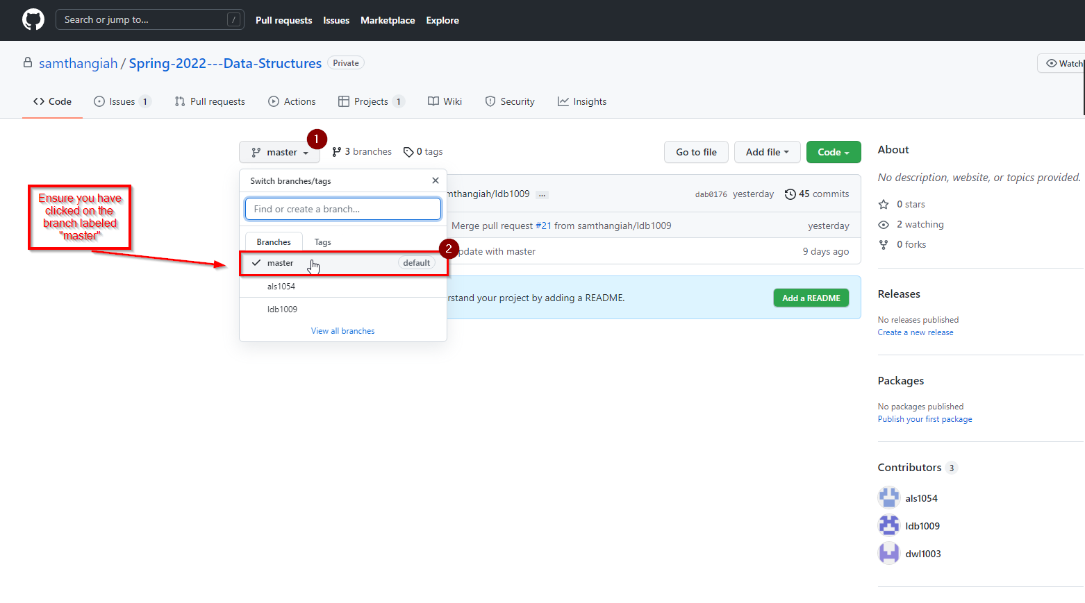

* After validating that you are in the master branch, click on the drop down arrow for **Code** and click **Download Zip:**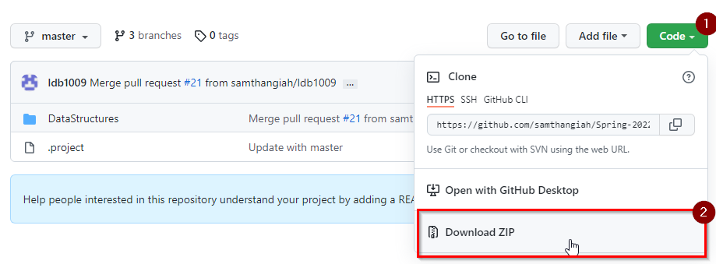

Figure 2 Diagram of Downloading Repository as ZIP

* The downloaded zip folder will be stored in your **Downloads** folder if you are using a windows device. Use your desired ZIP tool (WinRAR, 7zip) to unzip the archive. Open up the archive and extract the contents to your desired directory. Be sure to remember where you have extracted the zip folder to as we will need to use the location in a later step.
* Create a folder in your desired directory to store your eclipse workspace.
* Launch Eclipse and next to the **Workspace:** dropdown menu select **Browse…**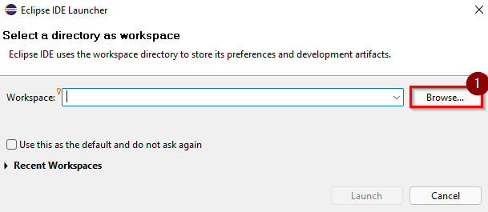

Figure 3 Diagram of Eclipse Startup

* Navigate to the location where we created the folder for our eclipse workspace. You can use the root directory of the extracted zip folder, or you can create your own folder. Either method works. For our example we are going to use the **Spring-2022---Data-Structures-master** folder to store our eclipse workspace.

After launching your workspace for the first time, you will need to import the downloaded workspace from github. In eclipse, navigate to **File>Import**. This will open the Import wizard. Open the **General** folder and select **Existing Projects into Workspace**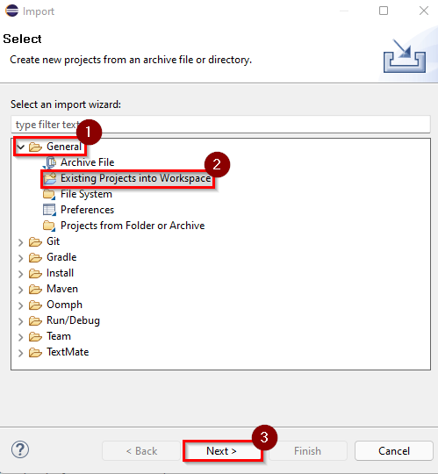

Figure 4 Diagram of Eclipse Import Using Existing Workspace

* In the **Import Projects** wizard, select **Browse…** next to the **Select root directory:** section.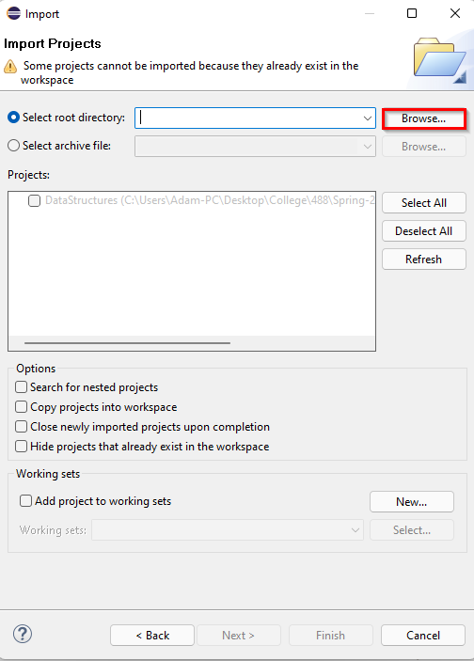

Figure 5 Diagram of First Page in the Import From Existing Workspace Wizard

* Now, we will need to navigate to the directory where we extracted the unzipped contents of our github repository. Once there, double-click on the **Spring-2022---Data-Structures-master** folder, click on the **DataStructures** folder, and press **Select Folder**

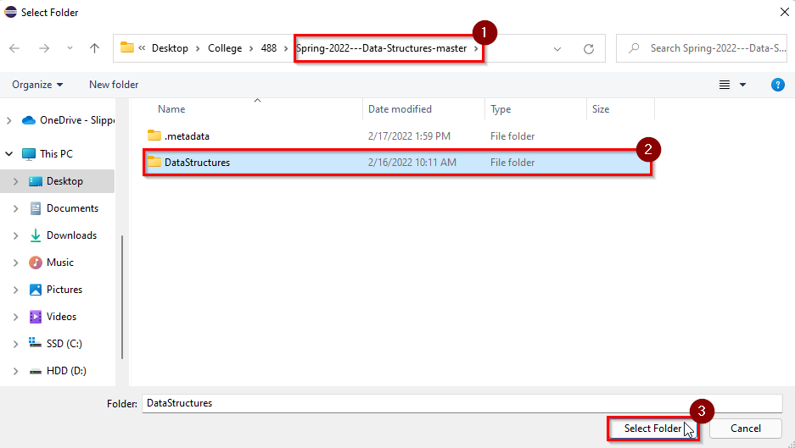

Figure 6 Diagram of Selecting Downloaded GitHub Workspace in File Explorer

* 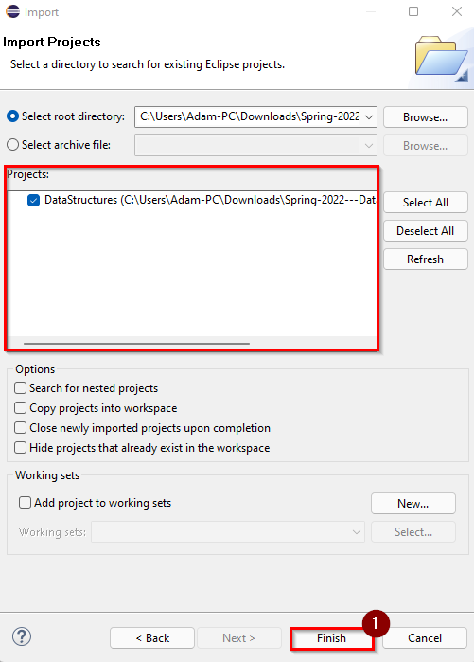After selecting the workspace to be imported, you will notice the workspace is enabled in the **Projects:** section. Click **Finish.**

Figure 7 Diagram of Final Page in Eclipse Import From Existing Workspace Wizard

* Opening the **Package Explorer** view (**Window > Show View > Package Explorer)** will now show the available packages and the workspace structure: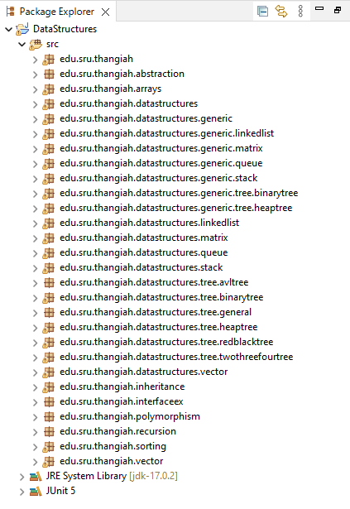

Figure 8 Diagram of Finished Eclipse Import From Existing Workspace